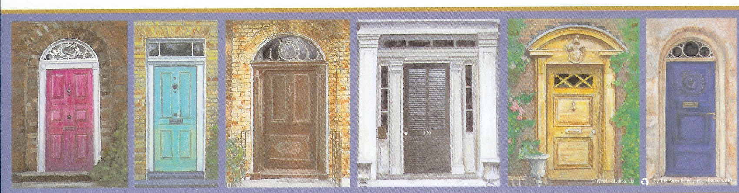
Rental Process

This information is intended to assist a prospective tenant in the rental process / steps to securing housing.

- View available rooms on the website.

- Contact landlord, Laurel Hays, via e-mail (haysrentals@comcast.net) or phone (843-822-5695) to schedule an appointment to view room.

- If interested in renting after viewing a room, 1) download rental application from the website, 2) complete application by typing into the excel document, 3) print, 4) sign, and 5) return to landlord via pre-arranged drop-off location.

- Landlord will complete a criminal background check, a credit check, and rental reference check usually taking approximately a day.

- If no problems are noted, Landlord will proceed by sending prospective tenant a lease via e-mail attachment.

- Tenant will download the lease, sign, forward to a parent to sign (if the prospective tenant is a student and/or under 23,) and return to Landlord along with the security deposit payment.

- Landlord will then sign the lease and forward tenant a copy along with move-in information. Keys will be distributed on or before scheduled move-in date, depending on when previous tenant moves out.

